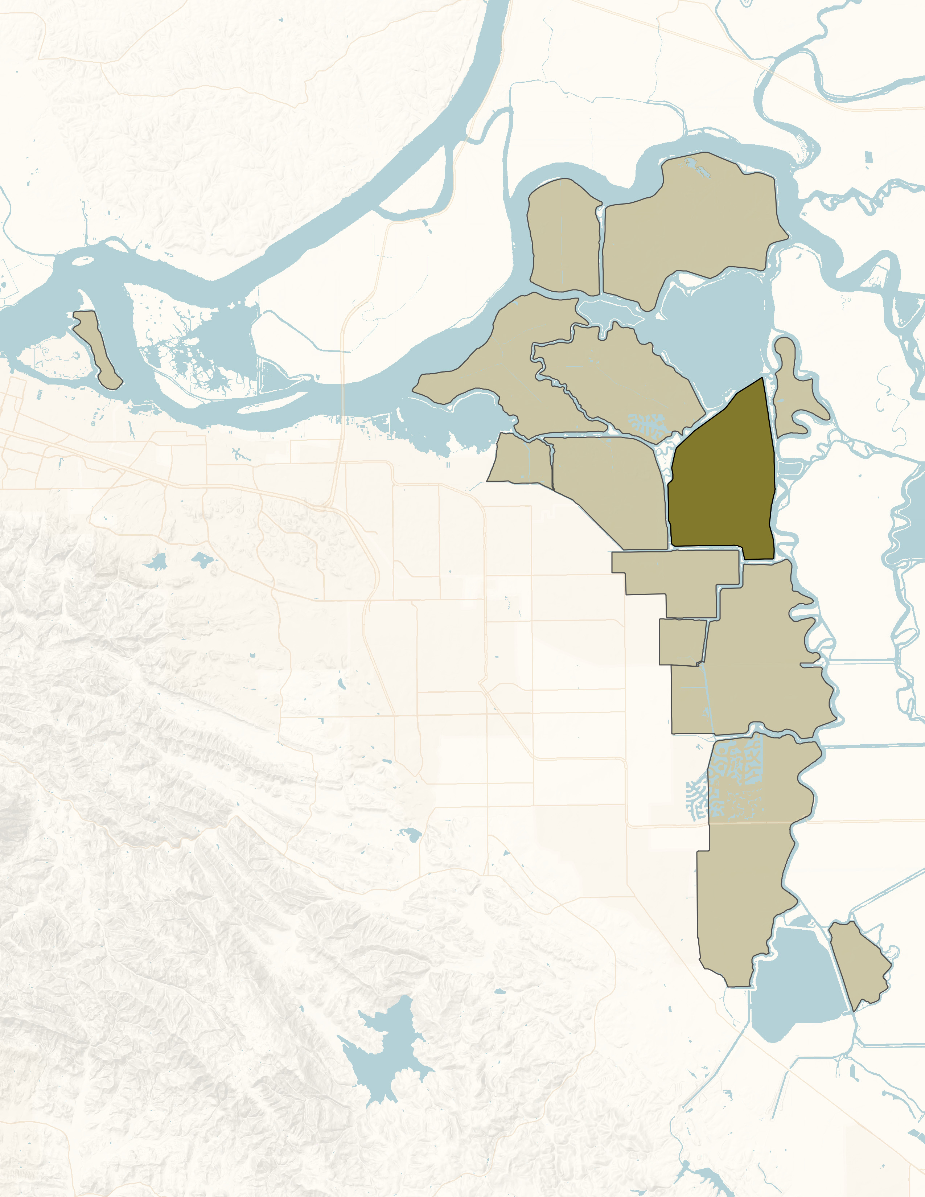
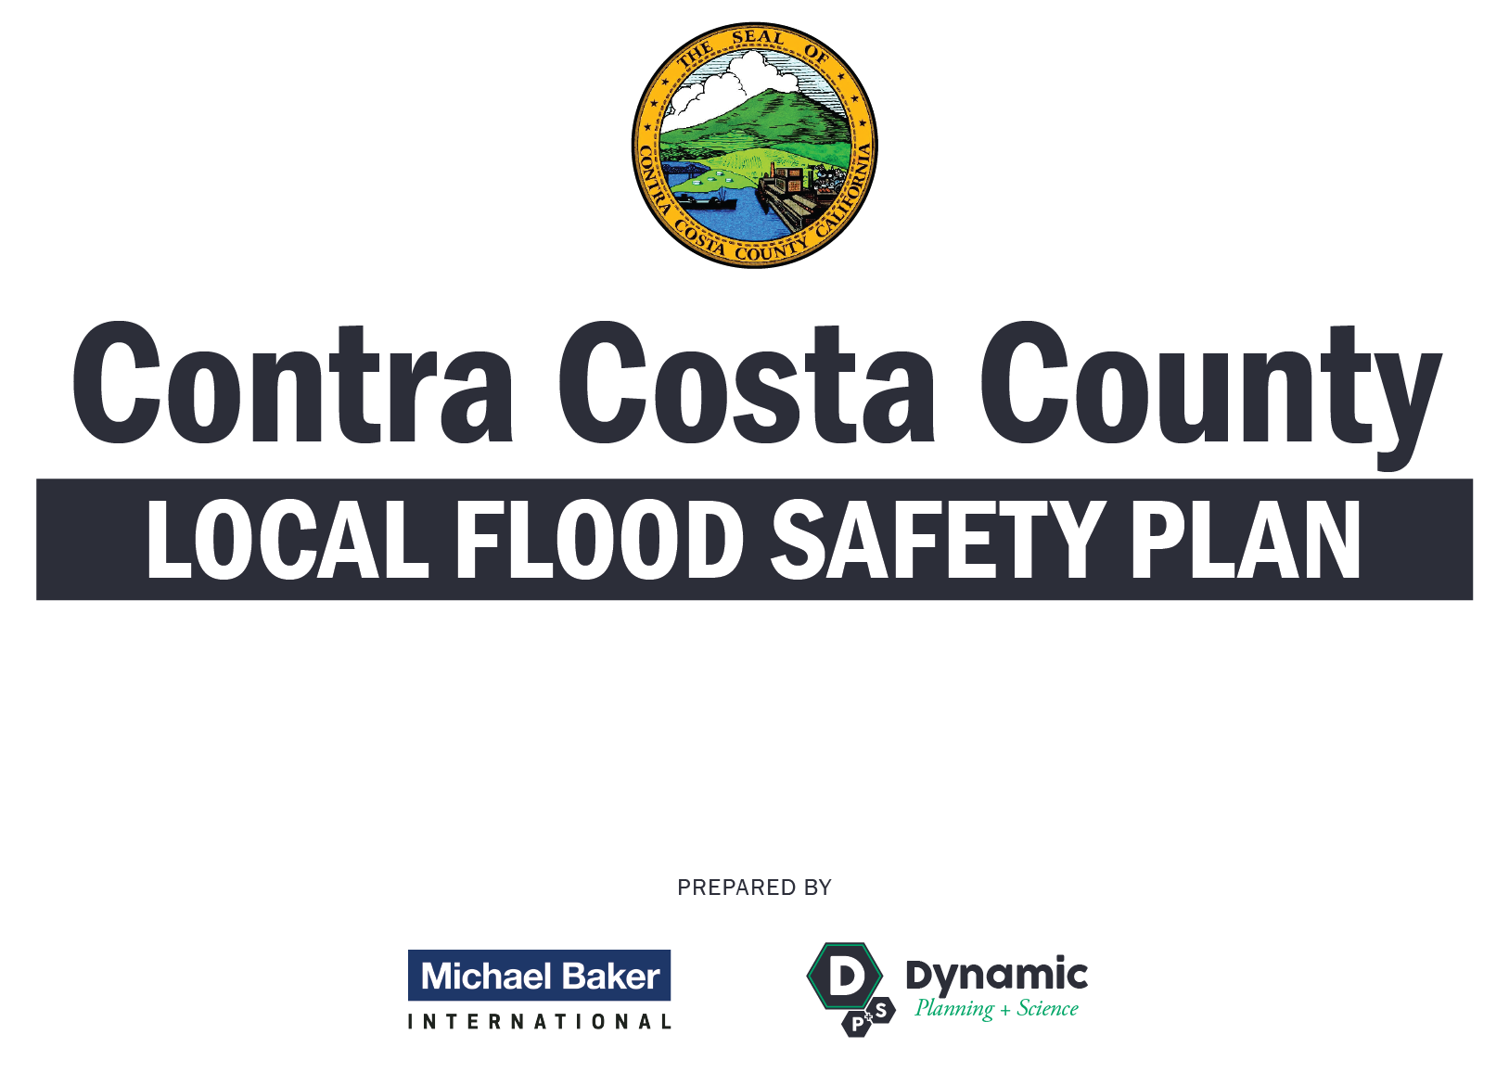
Final
May 2018

HOLLAND TRACT

RD 2025

INTENTIONAL BLANK PAGE

Plan Promulgation

  - HOLLAND TRACT LOCAL FLOOD SAFETY PLAN
  - PROMULGATION
It is crucial for Holland Tract to have complete and up-to-date plans to guide critical actions during a flood emergency event. Since 2007, the California Water Code (WC 9650) has specified several required elements for a Local Flood Safety Plan (LFSP). Thus, agencies and communities within Contra Costa County must adopt an LFSP with specific elements to be eligible for funds to upgrade their flood control facilities.
The Holland Tract LFSP is consistent with current policy guidance and describes interrelationships with other agencies. The LFSP will continue to evolve in response to lessons learned from actual disasters and emergency experiences, ongoing planning efforts, training and exercise activities, and State Department of Water Resources (DWR) guidance.
Therefore, in recognition of the flood-fighting responsibilities of Holland Tract and with the authority vested in me, I hereby promulgate the Holland Tract LFSP.
This LFSP will be distributed to appropriate officials and will be reviewed and updated on an annual basis, or earlier, based on lessons learned from exercises and real-world events.
DISCLAIMER
This Emergency Operations Plan (“Plan”) is intended to be a set of guidelines to be followed in the event of a flood emergency. Emergency conditions may vary significantly and may require that different elements of the Plan be utilized, depending upon the nature and extent of the particular emergency event, despite language in the Plan that appears to mandate certain actions. Notwithstanding anything to the contrary set forth in the Plan, including any language that appears to require particular action(s), the District preserves the ability to undertake all or any portion of the Plan as necessary and appropriate to respond to the particular emergency and preserve life and property. Under no circumstances will the District Board or its officers or employees be personally responsible for the procedures undertaken or not undertaken by Reclamation District No. 2025 in the event of a flood emergency, regardless of whether or not such procedures were included in the Plan.

Sign Here___________________________________

INTENTIONAL BLANK PAGE

Record of Changes

Date | Section | Description
May 2018 | 2.5 | Added Evacuation Plan
May 2018 | 6.6 | Added Evacuation Plan

INTENTIONAL BLANK PAGE
Table of Contents
SECTION 1. Plan Introduction 1
1.1 Purpose 1
1.2 Scope 1
1.3 Plan Structure 2
SECTION 2. Concept of Operations 3
2.1 Situation Overview 3
2.2 General Approach to Seasonal Flood Operations 6
2.2.1 Routine Preparedness and Infrastructure Maintenance 6
2.2.2 Monitoring and Analysis 6
2.2.3 Alerting, Activation, and Initial Response 9
2.3 Flood Fight Operations 10
2.3.1 General Flood Fight Strategy for High Water Events 10
2.3.2 Flood Contingency Options 11
2.3.2.1 General Flood Fight Options 11
2.3.2.2 Local Flood Contingency Planning Scenarios 16
2.4 Federal and State Disaster Assistance 18
2.5 Evacuation Plan 18
SECTION 3. Organization and Assignment of Responsibilities 19
3.1 Organization 19
3.2 Assignment of Responsibilities 19
3.2.1 Legal and Financial Commitments 20
3.2.2 Emergency Equipment, Supplies, and Resources Maintenance 20
3.2.3 Water Conditions, Elevations, and Forecast Monitoring 20
3.2.4 Staff and Activation during Emergency Operations 21
3.2.5 Expenditures, Emergency Actions, and Mutual Aid Documentation 21
SECTION 4. Direction, Control, and Coordination 23
4.1 Management and Control of Operations and Coordination 23
4.1.1 Management and Policy 23
4.1.2 Incident Command Facilities 23
4.2 Management and Coordination with Other Jurisdictions 23
4.2.1 Unified Flood Fight Command Post 23
4.2.2 Operational Area Emergency Operations Center 24
4.2.3 State-Federal Flood Operations Center 25
4.2.4 Operational Area Joint Information Center 25
SECTION 5. Communication 27
5.1 Communication Organization 27
5.2 Communication within Holland Tract 27
5.3 Communication with Other Jurisdictions 27
5.3.1 Operational Area Emergency Operation Center 27
5.3.2 Department of Water Resources State-Federal Flood Operations Center 28
SECTION 6. Logistics and Finance/Administration 29
6.1 Mutual Aid 29
6.2 Resources 29
6.3 Logistics Facilities 30
6.4 Finance and Administration 30
6.5 New Building Requirements 31
SECTION 7. Plan Review and Maintenance 32
7.1 Plan Review and Maintenance 32
7.2 Training and Exercises 32
7.2.1 Emergency Response and Training 32
7.2.1.1 Emergency Response 32
7.2.1.2 Training Requirements 32
7.3 Plan Evaluation 32
SECTION 8. Authorities and References 34
8.1 Federal 34
8.2 State 34
8.3 Local 34
SECTION 9. Glossary of Terms/Acronyms 36
Appendix A. Flood Contingency Map 38
Appendix B. Increased Readiness Checklist 40
Appendix C. Flood Water Removal (Dewatering) Options 42
Appendix D. Action and Event Progression Log 44
Appendix E. Emergency Personnel Contacts 46

List of Tables
Table 1: Special Flood Considerations 5
Table 2: Flood Contingency Options 17
Table 3: Contact Information 28
Table 4: Flood Fight Supply Inventory 29

List of Figures
Figure 1: Holland Tract Regional Location 4
Figure 2: Stream Gauge Locations 7
Figure 3: River Gauge Links 8
Figure 4: Levee Sack Topping Diagram 12
Figure 5: Muscle Wall 13
Figure 6: Levee Boil Diagram 14
Figure 7: Boil on Levee 14
Figure 8: Envelope Wind Wave Protection Method 16
Figure 9: LMA Boundaries and Incident Command Post (ICP) Locations 24
Figure 10: Regional EOC & ICP Map 25
Figure 11: Pre-positioned Flood Fight Materials, Supplies, and Headquarters 30

INTENTIONAL BLANK PAGE

Plan Introduction

Purpose
The purpose of this Local Flood Safety Plan (LFSP) is to ensure that response objectives in a flood emergency can be met within and around the impacted levee area in order to reduce injuries and the loss of human life and to minimize property damage. This plan is intended to be used in conjunction with the Emergency Operations Plan of Contra Costa County and to facilitate multi-jurisdictional coordination within the Reclamation District boundary.
This plan is a response support mechanism for levee maintaining agencies in the event of levee failure. Levee failure is the collapse or failure of an impoundment that causes significant downstream / island flooding. Levee failure primarily occurs due to overtopping or “piping” (internal erosion of soil particles resulting in a pathway for water flow). Failure from overtopping would occur if water spilled over the face of the dam, causing erosion of the downstream face which could lead to complete failure. This is most common during heavy rainstorms. Piping failure could occur at any elevation and could be related to seepage, internal erosion near conduits, or backward erosion piping from the downstream face. Seismic activity may also cause inundation by the action of a seismically-induced wave that overtops the dam without causing failure of the dam, but still floods downstream. Landslides flowing into a lake may also cause a dam to fail or overflow. The principle consequences of levee failure are injury, loss of life, and significant downstream property damage. Inundation, or flooding which occurs as a result of embankment or spillway structural failure of a levee, poses a serious threat to specific areas within Contra Costa County and surrounding areas.

Scope
This levee maintaining agency (e.g., Reclamation District or other special district), as an independent jurisdiction, has the responsibility for maintaining the levee and drainage systems within its jurisdictional boundaries. While Holland Tract will work with, and assist if possible, the local jurisdiction(s) responsible for other public safety functions within Holland Tract, this plan only contains detailed procedures for its emergency responsibilities. The manner of interacting with other jurisdictions is described, but the operational plans of other jurisdictions with public safety responsibilities within the area protected by Holland Tract levees are only referenced in this document.
This plan covers the following:
- Holland Tract Flood Preparedness Procedures
- Holland Tract Levee Patrol Procedures
- Holland Tract Flood Fight Procedures
- Holland Tract Flood Water Removal Procedures
- Holland Tract Recovery and After-Action Follow-up Procedures

Plan Structure
This plan is structured as a traditional functional Emergency Operations Plan in accordance with Comprehensive Preparedness Guide (CPG) 101, issued by the Federal Emergency Management Agency (FEMA). Consistent with that guidance, and the levee maintaining agency’s limited responsibilities and lack of internal departments, this LFSP consists of a Basic Plan, containing an overview of Holland Tract response procedures, and a hazard-specific annex in map format (Annex A – Flood Contingency Map).

Concept of Operations

Situation Overview
The Delta is affected by riverine flows from the Sacramento, San Joaquin, Cosumnes and Mokelumne rivers along with tidal conditions from the San Francisco Bay. Fed by runoff from the northern Sierra Nevada Mountains and the southern Cascades, the Sacramento River flows south to meet the northbound San Joaquin River just south of the City of Sacramento. Smaller tributaries and tidal flows combine with the Sacramento and San Joaquin Rivers to form a 700-mile maze of sloughs and waterways surrounding more than 60 leveed tracts of land or “islands.” The state and local protective facilities throughout the Delta region, such as dams, bypasses, and project levees, afford a level of flood protection; however, the flood events of 1986, 1995, 1997, 1998, and 2007 demonstrated that there is still a significant flood threat in the Delta region.
In all, there are more than 1,100 miles of levees in the Delta like those surrounding Dutch Slough, including many built more than a century ago to protect farmland. Approximately two-thirds of the Delta reclaimed lands are below sea level, and land owners rely on a maze of levees to protect valuable rural and urban land and key infrastructure from floods and daily high tides. The network of watercourses in the region are characterized predominantly by natural vegetation and limited channel capacity controlled by levees to protect the islands from inundation by floodwater.
Located on Old River in the central delta Holland Tract is vulnerable to several flooding sources caused predominantly by tidal, riverine action and wave run-up. Major waterways adjacent to Holland Tract include Sand Mound Slough, Rock Slough, Holland Cut, portions of Old River, and the water body of Franks Tract. (See Figure 1 and Appendix A.) Extreme high-water conditions within these waters are caused by a combination of coincident high tides and high river flows which can be extremely threatening to levee integrity. High river flows result when upstream reservoirs are full, and reservoir operators are forced to release water in high volumes downstream eventual effecting Delta water levels. Even with an average snowpack, major Pacific storm events can be a threat to low-lying areas of the Delta especially during king tides. When a Pineapple Express (a meteorological phenomenon characterized by a strong and persistent flow of atmospheric moisture and associated with heavy precipitation from the waters adjacent to the Hawaiian Islands and extending to any location along the Pacific coast of North America) occurs, Holland Tract is vulnerable to flooding from a number of sources, including excessive runoff in the mountain regions and related reservoir releases. Even with an average snowpack, major Pacific storm events can be a threat to low-lying areas of the Delta, especially during King Tides. When a “Pineapple Express” (a meteorological phenomenon characterized by a strong and persistent flow of atmospheric moisture) occurs, its rain events can melt snowpack in the mountain regions, and reservoir operators are forced to release excess water capacity. Other threats include backwater flooding and drainage pump failures. These events may produce localized flooding and losses to Holland Tract infrastructure and private property. Profound flooding caused by levee failure or overtopping remains a threat in this area as well.
Localized conditions or “special flood considerations” exist for every tract of land in the Delta region. Special considerations may include information on critical infrastructure, hydraulic features, and other information that could affect a flood-fighting strategy in a local setting. Table 1 presents the special flood considerations for Holland Tract; this information is also presented in Annex A – Flood Contingency Map.
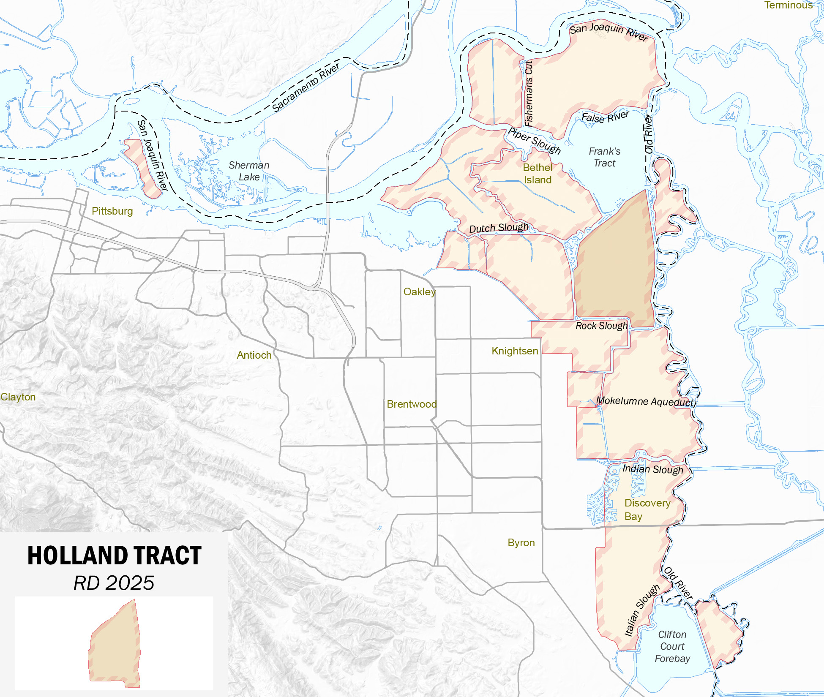
Figure 1: Holland Tract Regional Location

Table 1: Special Flood Considerations
Symbol | SFC Number | Heading | Description
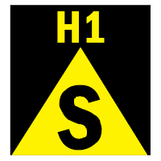 | H1 | Pump Station 1 | Located near station 19+00. Discharge pump may be used during a major flood event; however, additional pumps would be required to dewater the island.
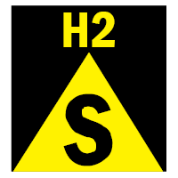 | H2 | Pump Station 2 | Located near station 73+00. Discharge pump may be used during a major flood event; however, additional pumps would be required to dewater the island.
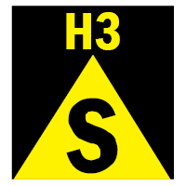 | H3 | Pump Station 3 | Located near station 239+00. Discharge pump may be used during a major flood event; however, additional pumps would be required to dewater the island.
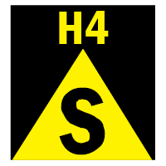 | H4 | Holland Tract Bridge | Holland Tract Bridge is the only motor vehicle egress for Holland Tract. A secondary bridge is located in the general vicinity of Sandmound Blvd. Contact the local Reclamation District to gain access to Sandmound Blvd in the event of an emergency.
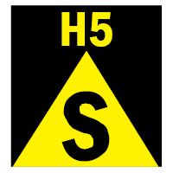 | H5 | Franks Track Open Water | The flooding threat is predominantly tidal, with some local runoff that can influence conditions. The Old River (on the east side of the island) could pose a riverine flooding threat. Franks Tract (large expanse of open water) can create erosion due to wind/waves.
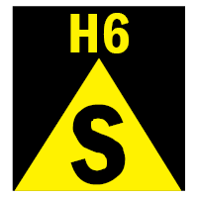 | H6 | Wave Fetch | The wave fetch is relatively short on the southern, eastern, and western portions of the island and is generally not a concern over much of the District. The northern portion of the island has a wave fetch of up to 3.5 miles across Franks Tract. Channel widths generally vary from 150 to 1,450 feet. The levees are armored with riprap, except some areas along the southern and eastern levees.
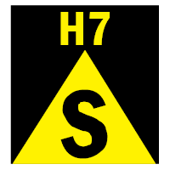 | H7 | Levee Status | There is no levee certification status for Holland Tract. The levee geometry generally meets the PL 84-99 Delta Specific Standard.
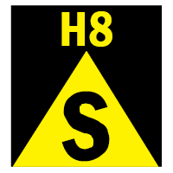 | H8 | Tract Inhabitants | Two active marinas are located along the south levee (Lindquist Landing and Holland Riverside Marina), with up to 40 inhabitants living boats at any given time.
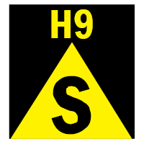 | H9 | Levee Access | County-maintained road is located on the crown of the south levee and portions of the east levee.
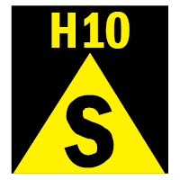 | H10 | Land Uses | Portions of the island are farmed or leased for grazing, with operations supported by various facilities and equipment. The island also has permanent habitat sites.
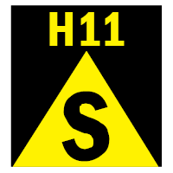 | H11 | Pump Station Infrastructure | Infrastructure includes pumping stations for drainage and associated electrical lines.
See Annex A – Flood Contingency Map for Holland Tract jurisdictional boundaries, levees, pumping stations, supply depots, historical flooding summary, locations of past breaches, areas of historic seepage or erosion, topography, and characteristics of the waterways fronting Holland Tract levees.

General Approach to Seasonal Flood Operations
The levees are patrolled on a daily basis. The District Engineer tours and inspects the levees in his normal routine. The District Engineer inspects the levees as needed during the year to identify problem areas, which are then improved. Flood fight supply inventory is checked and updated.

Routine Preparedness and Infrastructure Maintenance
Levees are periodically inspected by the District Engineer and Reclamation District (RD) personnel. Problems are identified and actions taken as necessary. Pumps are operated and maintained by RD personnel and outside contractors. Pumps are inspected and maintained as necessary. Drainage ditches are cleaned on an as-needed basis.

Monitoring and Analysis
The Delta Tide Forecast is monitored using the Antioch Gauge (ANH). A secondary gauge, Holland Cut (HOL) near Bethel Island, is also monitored. The trustees and the District Engineer monitor weather reports.
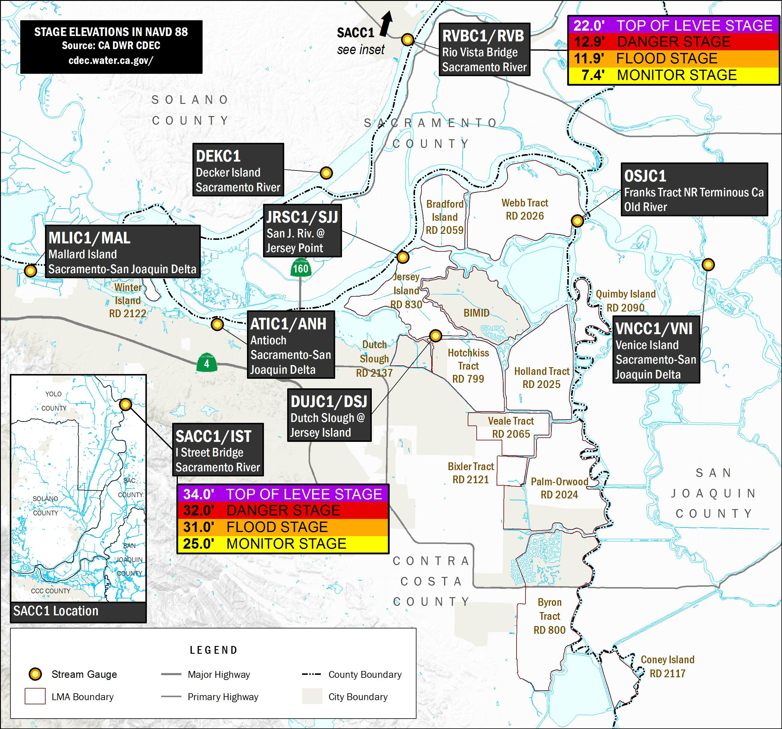
Figure 2: Stream Gauge Locations
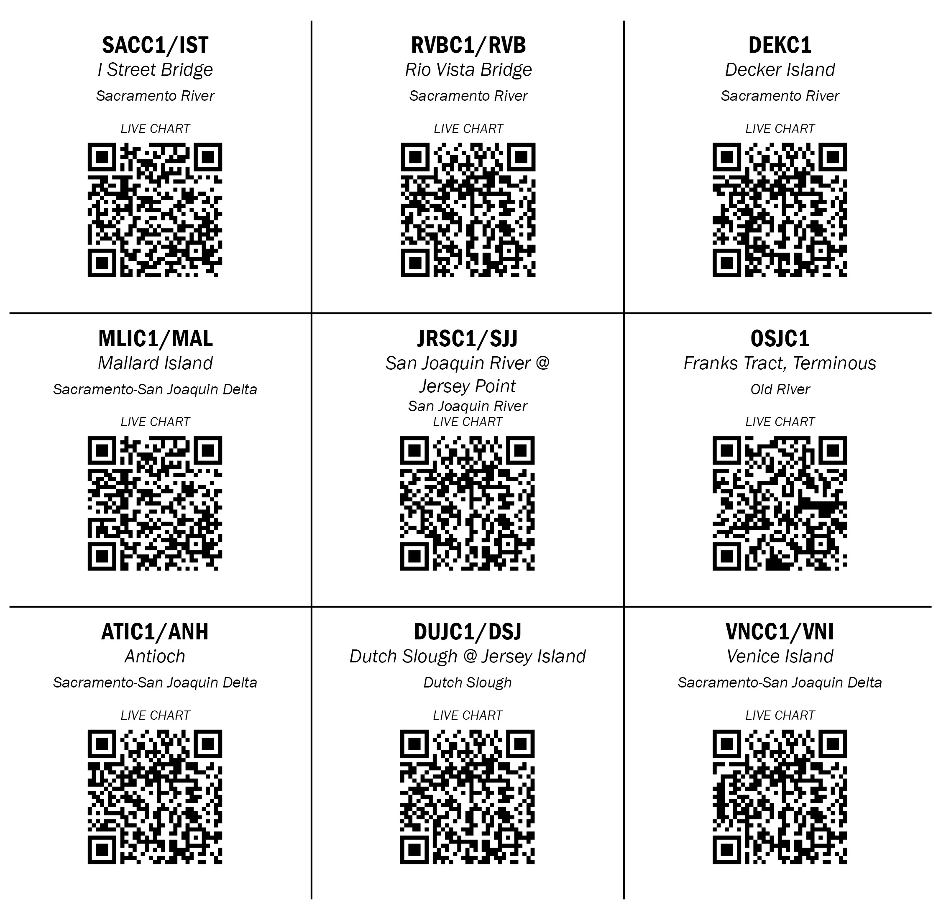
Figure 3: River Gauge Links
The Rio Vista Bridge (RVBC1) Stage Heights should be used to validate locally known high water marks. Figure 3 provides river stage height definitions for the Rio Vista Bridge; these definitions could be relevant in the event of high water in local operational areas.
Download and view information on local river gauges and tides from:
NWS: http://water.weather.gov/ahps2/index.php?wfo=mtr
California Data Exchange Center: http://cdec.water.ca.gov/cdecstation/
Download current National Oceanic and Atmospheric Administration (NOAA) observation. Keyhole markup (KMZ) Google Earth data for Weather Forecast Office San Francisco Bay Area, California here: http://water.weather.gov/ahps2/download.php?data=kmz_obs&wfo=mtr
Delta Tide Forecast: http://cdec.water.ca.gov/cgi-progs/rivfcast/TIDES

Alerting, Activation, and Initial Response
Previously identified markers and information sources will be monitored and will trigger the response actions. Holland Tract staff may take these and additional actions when it is felt that conditions affecting the levees and drainage system warrant such action.
The primary gauge that is monitored is the Antioch Gauge (ANH). The 100-year flood elevation for this gauge is 9.4 feet (NAVD 88). Holland Tract staff will also take the following actions upon the identification, or verified report, of any out-of-the-ordinary condition on a Holland Tract levee that presents a potential risk:
Table 2: Antioch Gauge (ANH) Alert and Notification Monitoring Heights
FT | Flood Stage Description
EL. 8.9’ | Emergency Response - River Flood Stage:  Contact the Contra Costa County Sheriff’s Office (responsible for public safety within Holland Tract) when there is a potential threat to levee integrity.
EL. 8.4’ | Emergency Response - River Danger Stage:  Initiate levee patrols when ANH reaches a stage of 8.4, or 1 foot below the 100-year flood elevation.
EL.7.9’ | Increased Readiness - Monitor/Preliminary Response Actions:  Activate Levee Maintaining Agency (LMA) staff, LMA field command post, and/or emergency operations center when ANH reaches a stage of 7.9, or 1.5 feet below the 100-year flood elevation.
EL.7.9’ | Normal Preparedness (Routine Activities):  Alert LMA board of directors/trustees and staff when ANH reaches a stage of 7.9, or 1.5 feet below the 100-year flood elevation.
About this gauge location: Latitude: 38.159722° N, Longitude: 121.686389° W, Horizontal Datum: NAD83/WGS84 Vertical Datum: NAVD88. Elevation information source; Survey grade GPS equipment, FEMA flood plain maps, newer United States Geological Survey (USGS) topographic maps.
The District does not use “phases,” where objective conditions trigger a group of actions. Each action indicated will be taken upon reaching the trigger condition shown or if District staff feels it is warranted. As noted below, the District Engineer is responsible for monitoring objective conditions affecting the District.
The District Engineer will notify the Contra Costa County Sheriff’s Office of identified threats to its levees or internal drainage system and will provide detailed information on the characteristics of the threat. The District Engineer will assist, to the greatest extent possible, with notification of residents if requested. This includes implementing an evacuation plan that includes a system for adequately warning the public in the event of a levee failure and evacuation.
IMPORTANT TO NOTE: For an unexpected levee failure or threat of imminent failure, contact the DWR Flood Operations Center (916-514-2619) for emergency response assistance and flood fight strategy.

Flood Fight Operations
Annex A–Flood Contingency Map displays Holland Tract’s concept of operations for emergency communications and patrol for the period before State or Federal agencies assume control over the flood fight and dewatering operations. This concept of operations will be modified as needed to meet the demands of actual emergency conditions.

General Flood Fight Strategy for High Water Events
The general flood fight strategy will be to protect the perimeter or primary levees protecting people and property. Emergency flood fight measures should be coordinated and supervised by RDs, LMAs, and/or a combination of levee owners and flood control device operators. The primary flood fight strategy is to patrol primary levees, ensure flood control devices remain operational, and monitor the situation for any levee distress or threat of imminent failure.
The flood fight personnel will coordinate levee patrols with county, State, and Federal teams assigned to assess and/or fight flooding on private, State, and Federal levees. County Emergency Services should be contacted to address imminent failure threats. County Emergency Services should coordinate action planning between levee districts and State/Federal agencies and provide logistical support when necessary. In the event that access from land or water is restricted due to the flood, local flood fight personnel will monitor and arrange to implement emergency access plans with the specific county Office of Emergency Services (OES) in the region.
For an unexpected levee failure or threat of imminent failure, contact the DWR Flood Operations Center (916-514-2619) for emergency response assistance and flood fight strategy.
General Flood Fight Actions:
1) Upon receipt of high water notification, the local maintaining agency should establish a levee patrol, form a skeleton organization capable of quick expansion, and assign individuals to have charge of specific sections of levees. In order to provide proper condition assessments, maintain an adequate number of patrol and flood fight personnel.
2) Maintain detailed inspection reports, particularly with reference to the following matters: condition of levees and recent repairs, road crossings or other locations where the levee is below grade, culverts, flap gates, sluice gates and trash racks. Report all levee erosion, slumping, seepage and/or boils forming.
3) Obtain and distribute necessary tools and flood fight materials (sacks, sandbags, brush, lumber, lights, etc.) at points where flood maintenance is anticipated. Fill any holes or washes found in the levee with compacted material. Repair gaps where road crossings have worn down the levee crown or other locations where the levee is below grade; identify any right-of-way encroachment that could impede access and efficient operation, and determine any action required.
4) If flooding is imminent, make requests as appropriate to local, State, and Federal personnel for assistance with flood fight resources. Verify evacuation plans with emergency response agencies. Verify and establish supply staging areas, procure and pre-position equipment, establish a plan for moving resources into the area in the event that land access is degraded. Review specific protective actions to protect vital facilities in event of flooding. Evaluate a secondary line of defense if primary levees fail (i.e., required height of inland levees and Preliminary Engineering Design (PED) plans, if they exist). Calculate the amount of material necessary to implement the PED and other protection methods, and coordinate with local suppliers and emergency management (EM)ROC personnel. Verify emergency power to maintain pump stations and other flood control structures. Locate transportation resources, including available trucks and heavy hauling equipment.

Flood Contingency Options
The main causes of levee failure or flood-related problems due to high water are:
- Overtopping resulting from water-surface elevations higher than the levee or embankment;
- Seepage through or under the levee that is heavy enough to cause a “boil;” and
- Erosion of the levee or embankment due to swiftly moving water or wave action.

General Flood Fight Options
Generic Scenario: Overtopping (Rainy Day Tide/Rain)
If any levee reach or stream bank is lower than the anticipated high water elevation, an emergency topping should be constructed to raise the grade above the forecast flood height. A sack topping may be required at road or stock crossings, low levee sections, or railroad crossings. The following sections discuss various methods for increasing levee and bank elevations.
Flood Fight Method 1: Sack ToppinG
The most common form of flood control work is using sandbags to construct temporary walls. The use of sandbag walls to increase the height of a levee section is called “sack topping.” The sacks are laid as “stretcher rows,” or along the levee. The sacks should overlap by at least one-third of the bag and be stomped firmly into place. When properly placed and compacted, one sack layer will provide about 3 to 4 inches of topping.
Necessary Material for 100 FEET of Levee Protection:
Sandbags
- 600 – 1 foot high x 100 linear feet
- 2,100 – 2 feet high x 100 linear feet
- 4,500 – 3 feet high x 100 linear feet
- 7,800 – 4 feet high x 100 linear feet
Sand or similar earthen material (0.5 cubic feet per sandbag)
- 300 cubic feet – 1 foot high x 100 linear feet
- 1,050 cubic feet – 2 feet high x 100 linear feet
- 2,250 cubic feet – 3 feet high x 100 linear feet
- 3,900 cubic feet – 4 feet high x 100 linear feet
Labor: 3-person team fills 2 bags per minute average over an hour, or 120 bags per hour
- 5 hours – 1 foot high x 100 linear feet
- 17.5 hours – 2 feet high x 100 linear feet
- 37.5 hours – 3 feet high x 100 linear feet
- 65 hours – 4 feet high x 100 linear feet
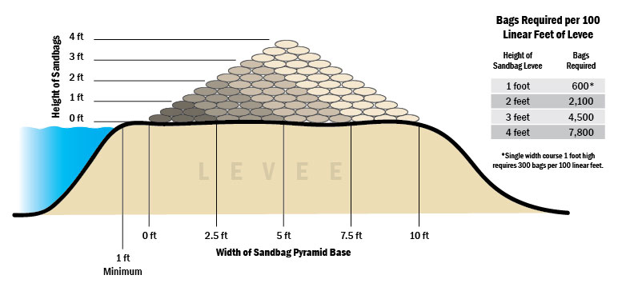
Figure 4: Levee Sack Topping Diagram

Flood Fight Method 2: Temporary Earthen Levee
This method is used to raise low areas during high water periods to prevent overtopping of levees, stream and riverbanks, small earthen dams, roadways, etc. To raise low areas, unfold a 20-foot x 100-foot x 10-mil roll of plastic sheeting and lay it out flat on the area to be raised. Place fill material on the plastic. Fold the plastic over the material, and lay a single row of sandbags on the backside lip of the plastic and on all seams. Fill material can be placed using a bottom dump or dump bed truck or a front-end loader, or manually.
Necessary Material for 100 FEET of Levee Protection:
- 2 rolls of 10-mil plastic sheeting
- 4.5 cubic yards of earthen material
- 30 sandbags
Flood Fight Method 3: Muscle Wall Temporary Levee (2-foot Wall)
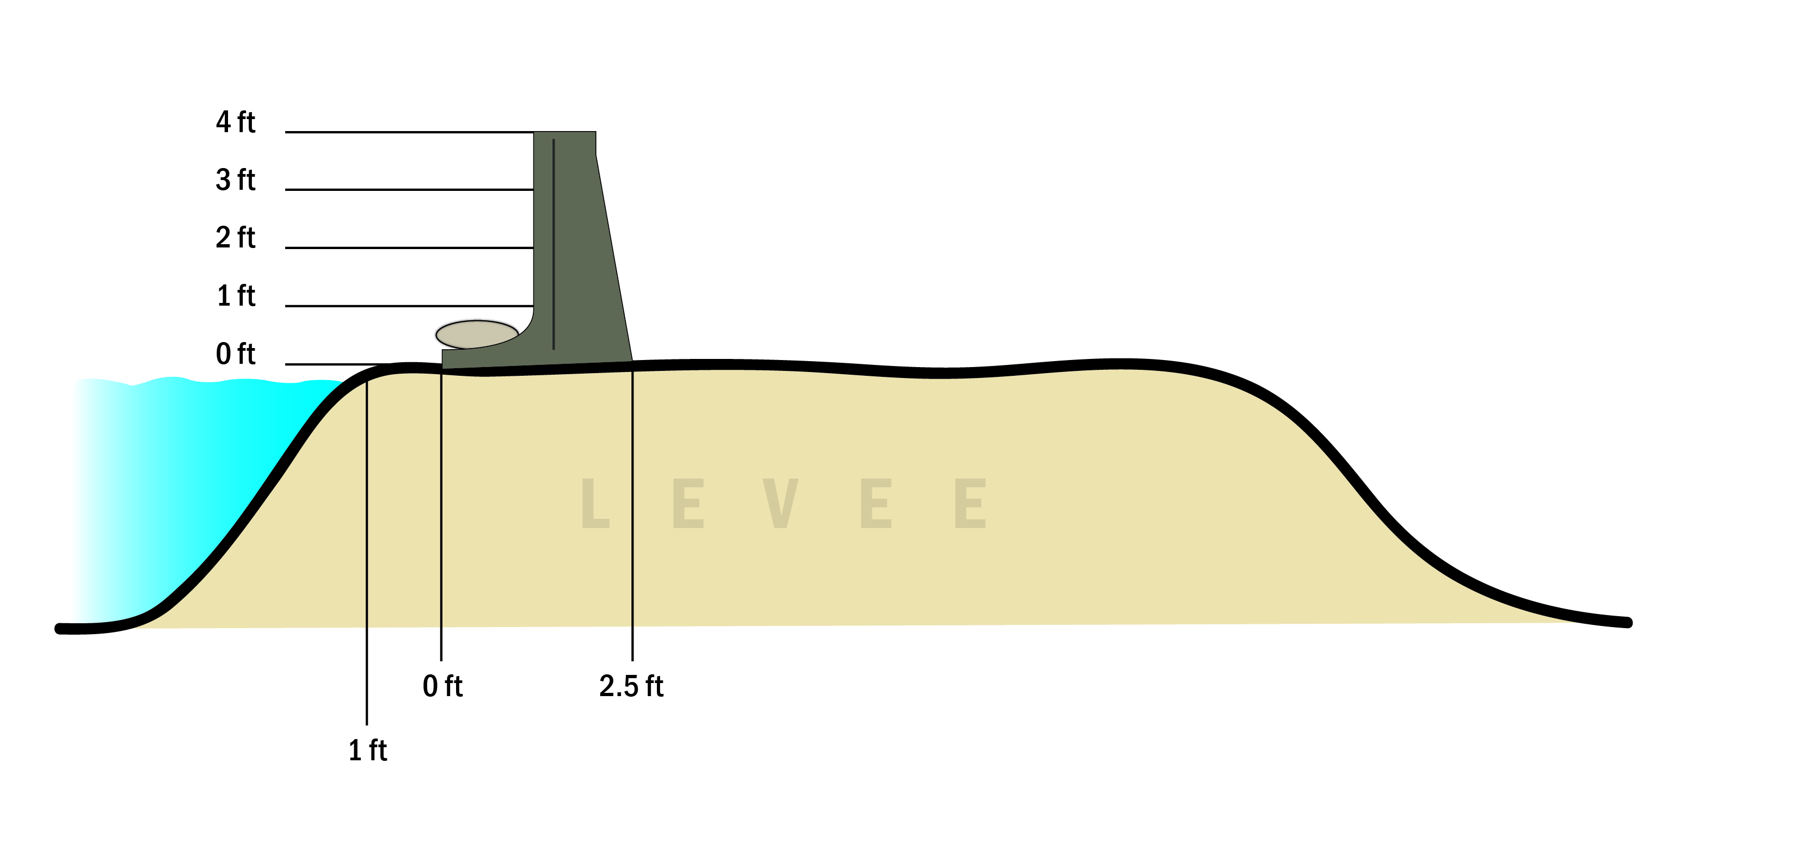
Muscle Walls are water-filled, rigid, molded plastic containers that are interlocked on site by manually lifting a container’s tongue end over the groove end of another container and sliding them together. Each container is 6 feet long, 2 feet high, and 2.5 feet wide, and provides an impervious water barrier (apron and wall). The minimum footprint is 10 feet of width to accommodate a 4-foot apron, the barricade, and a 4-foot monitoring and seepage management area. This is designed for even and firm terrain with minor seepage on impervious surfaces.
Figure 5: Muscle Wall
Necessary Material for 100 FeeT of Levee Protection:
- 10 sandbags for every section of Muscle Wall
- Gloves
- 500-1,000 feet of string
- Trash pump
- Forklift
- Lifting dolly
- Gorilla tape
- Pressure washer
- “Great Stuff” foam sealant (for impervious surface)
- 2 razor knives
- Trencher
- Shovels
- 200-foot measuring tape
- Marking paint
- 2 sledgehammers

Generic Scenario: Boil
Boil is a condition that occurs when water is “piped” through or under a levee and resurfaces on the landside. These weak points are generally caused by burrowing rodents or decomposed tree roots. High water pressure can begin to erode the interior of the levee and weaken the structure. Levee material will deposit around the exit point as the water discharges on the landside. If the boil is determined to be “carrying material,” then corrective action is required to control the situation. If left unattended, the material that makes up the levee can be eroded at an accelerated pace, causing subsidence and overtopping of the levee. This could result in a levee break.
Flood Fight Method: Common Boil Control
The common method for controlling a boil is to create a watertight sack ring around it. The sandbag structure should be high enough to slow the velocity of the water and prevent further discharge of material from the boil. The flow of water should never be stopped completely, since this may cause the boil to “break out” in an area near the existing sack ring. A spillway must be constructed to direct water away from all boil sites. The sack ring should be large enough to encompass the area immediately surrounding the discharge point (3 to 4 feet in diameter). If several boils carrying material are found, a single large sack ring may be constructed around the entire “nest” of boils.
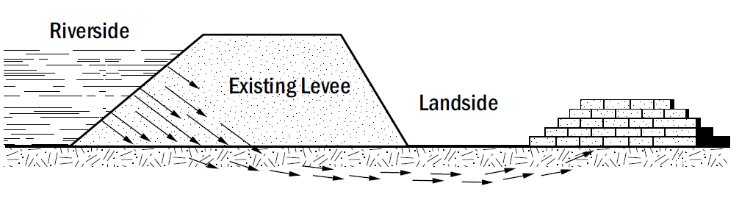
Figure 6: Levee Boil Diagram
Flood Fight Method: Levee Slope Boil Control
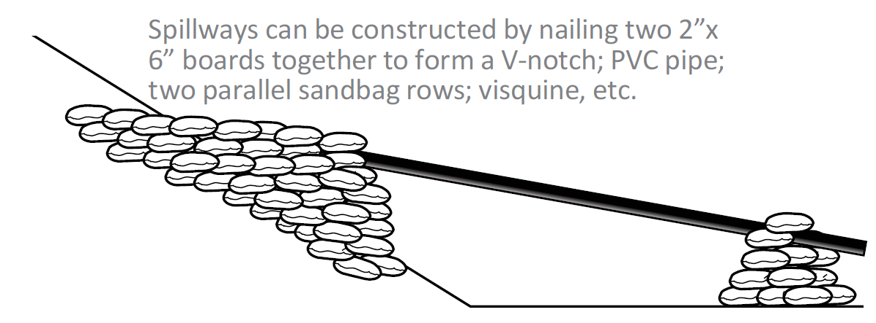
If the boil is close to or on the levee slope, a U-shaped sack ring may be built around the boil and keyed into the slope. Construction of this method can be difficult and requires substantial shoring up of the U-shaped sack ring structure. A spillway must be constructed to direct water away from all boil sites.
Figure 7: Boil on Levee
Necessary Material for 100 FeeT of Levee Protection:
- 100 sandbags per boil
- 15 cubic feet of sand or similar earthen material
Generic Scenario: Wind / Wave wash
All levees adjacent to wide stretches of water should be watched during periods of strong wind, to detect the early stages of wave wash erosion. If the slope is well sodded, short periods of high wind should cause little damage. However, during sustained periods of strong wind and high water, experienced personnel should observe and monitor the affected areas.
Flood Fight Method: Envelope Wave Wash Protection
When used correctly, plastic sheeting is useful for wave wash protection. Visqueen should be purchased in 10-mil rolls, 20 feet wide by 100 feet long. Drive 1-inch x 3-inch x 2-foot wooden stakes into the ground just above the levee shoulder on the side you wish to protect. Place the stakes 4 feet apart and stagger vertically by 1 foot.
Avoid driving stakes in a straight line; this can cause cracking and sloughing of the slope. To provide added strength and leverage, drive stakes at a slight angle away from the water source with the wide (3-inch) side facing the water. Be sure the stakes are well into the ground and are secure.
When rolling out the plastic sheeting, it is helpful to use a shovel or similar long-handled tool. Eight to ten people should assist in shaking out the folds of the envelope. Be sure that both layers are held while the envelope is shaken out.
While flood workers hold the plastic securely, toss tied sandbags into the bottom of the envelope, with a 1-foot gap between bags. The tied bags provide weight to hold the plastic against the levee slope.
A tie-down button or small stone (preferably round) is secured through both layers of Visqueen. If a stone is used, tie a slipknot and double half-hitch to secure it. Fasten buttons to the Visqueen and tie off to the stakes using a minimum 250-lb. tensile strength twine with these points in mind: the plastic sheeting is secured using tie down buttons. To attach plastic buttons to the plastic, tie a slipknot on the end of the twine; slip loop over button and plastic, and draw tight. Tie two half-hitch knots around the throat of the plastic sheeting.
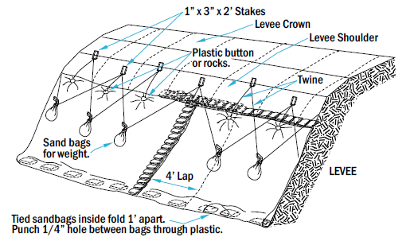
Necessary Material for 100 FeeT of Levee Protection:
Figure 8: Envelope Wind Wave Protection Method
- 2 rolls (20 feet x 100 feet) of 10-mil plastic sheeting
- 30 sandbags
- 2 rolls twine
- 10 plastic buttons or rocks
- 20 1-inch x 3-inch x 2-foot stakes
- 15 cubic feet of sand or similar earthen material

Local Flood Contingency Planning Scenarios
Flood contingency planning is preparation for flood hazards centered upon specific situations that may happen during high-water events; it is based upon a complete operational picture that includes historic information, special hydrologic considerations, planned engineering events, and resource availability.
Depending on the local landscape, resource availability, and expected flood direction, special actions and responsibilities for flood fight strategies may change based upon the real-time situation. Multiple flood fight strategies may be developed based upon failures of particular levees, location of threats, the value of the land, and/or population densities. The planned actions or “flood contingency planning” can reduce the risk of catastrophic damage and enhance the ability of emergency operators to make sound decisions quickly. Table 2 presents flood contingency options for Holland Tract; this information is also presented in Annex A – Flood Contingency Map.

Table 2: Flood Contingency Options
Symbol | FCO  Number | Heading | Description | Actions
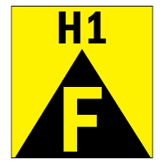 | H1 | High Water Event | Multiple high water events caused by large volumes of discharge from regional and local drainage systems, coupled with tides and low atmospheric pressure. Vulnerable area approximately 2,000 feet. Muscle wall or temporary earthen levee is recommended. | The District maintains stockpiles of riprap on the island and has equipment available to perform levee maintenance and repairs.  1. Deploy flood fight materials to prevent levee degradation and activate the workforce for levee patrols.  2. Prepare resources for a temporary earthen levee or muscle wall.  Muscle Wall Material Required:  A 2,000-foot temporary levee will require approximately 334 segments of muscle wall, 3,340 sandbags, or 1,670 cubic feet of sand.  OR  Temporary Earthen Levee Material Required:  A 2,000-foot temporary earthen levee (2 feet high x 4 feet wide) will require approximately 40 rolls of 10-mil plastic sheeting, 600 sandbags, or 90 cubic yards of fill. Approximately 11.1 cubic yards of fill are needed for sandbags, and 78.9 cubic yards for Visqueen fill.
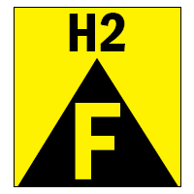 | H2 | Wave Wash | Wind waves could occur at this location. Wind waves causing erosion will lead to levee failure if not addressed for long periods of time; protection area approximately 1,000 feet. | The District has flood fight materials stored on-island for use during a flood fight.  1. Deploy flood fight materials to prevent levee degradation.  2. Protect area exposed to wind waves with envelope-style wrap.  Wave Wash Protection Material Required:  1,000 feet of envelope wave wash will require approximately 20 rolls of 10-mil plastic sheeting, 300 sandbags, 150 cubic feet of sand, 20 rolls of twine, 100 plastic buttons or rocks, and 200 [1-inch x 3-inch x 2-foot] stakes.
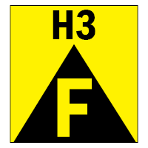 | H3 | Boil | Boil events caused by large volumes of discharge from regional and local drainage systems, coupled with tides and low atmospheric pressure. | 1. Protect area exposed to wind waves with boil ring.

Federal and State Disaster Assistance
The District’s policy is to maintain mitigation and emergency plans and procedures, as well as the physical condition of its levees, at the level required to be eligible for disaster assistance under the Federal Stafford Act program as well as the California Disaster Assistance Act (CDAA). Emergency operations will be conducted and documented in compliance with conditions of those programs for reimbursement of disaster expenses. To ensure that the District takes steps to quickly access the recovery process, these actions should be considered if an incident is imminent or occurring:
- Ask Contra Costa County to proclaim the existence of a local emergency
- Notify the District administration when the proclamation is established
The District Engineer will also maintain documentation during the event and process claims during the recovery period.
Holland Tract is not in the Flood Control Subventions Program, which provides financial assistance to entities cooperating in the construction of federally authorized flood control projects. RD 2025 may consider the following:
State and federal support during the Emergency Phase:
- Holland Tract may consider requesting support from the county and DWR during the Emergency Response Phase. California Mutual Aid and U.S. Army Corps of Engineers (USACE) assistance are available when resources beyond local capabilities are needed for flood fighting operations.

Emergency Phase support following flooding:
- If the county declares a disaster, the Governor may support it by proclaiming a State of Emergency and then asking the President of the United States to make a National Disaster Declaration for the affected area.
- If the President declares the area a national disaster, assistance from FEMA will be requested.
- If residential flooding occurs, regardless of the declaration, the USACE can provide Federal funds for recovery operations for up to 30 days following the incident.
- USACE assistance can also be requested to repair eroded and damaged levees following high flows. Request for this authority must be made in a timely manner (30 days).

Evacuation Plan
The Contra Costa County (CCCO) Sheriff’s Office is responsible for alerting, warning, and evacuating the public through the CCCO Operational Area using the procedures contained in the CCCO Emergency Operations Plan. If there is imminent threat of a failure of the levees or an actual breach occurs, the District is responsible for calling 911 to initiate the evacuation of the residents under the direction of the Sheriff’s Department. The Board and/or District Engineer will also assist, to the greatest extent possible, with notification of residents if requested. Ultimately the Sheriff’s office will conduct the actual evacuation with Office of Emergency Services (OES) assistance.
Residents with special transportation and evacuation needs exist in this area and should be coordinated through the County Sheriff’s Department and OES. Rally Point locations serve as safe havens that accommodate evacuees waiting further instructions for sheltering and provide protection from inclement weather. The primary mode of transportation in an evacuation will be privately owned vehicles. However, some individuals may not own a car or, for whatever reason, cannot drive or in an emergency may not choose to drive. Supplemental transportation resources must be provided for these "carless" populations by the County OES.

Organization and Assignment of Responsibilities

Organization
The District Board of Supervisors will use its paid, contract, and volunteer staff to perform its responsibilities in a flood emergency.

Assignment of Responsibilities
There are no specific limitations on the level of authority; however, the trustees consider the current financial state of the District prior to making decisions. Conditions vary, so each situation is evaluated on a case-by-case basis.
The following are assignments of authority and responsibility to ensure that needed emergency actions can be taken promptly and efficiently.
District ENGINEER Duties
The District Engineer is in charge of emergency levee patrols and emergency response and shall use judgment as to when to initiate emergency patrols. Emergency patrols supplement the regular levee patrols performed by the District Engineer during normal working hours. Generally, emergency patrols are to be initiated after earthquakes and during severe storms, winds, and periods of high water. The District Engineer contacts the county sheriff and the Office of Emergency Services upon deciding to initiate an emergency patrol. The District Engineer will supply the manpower and vehicles to patrol the levee.
The District Engineer is authorized to hire contractors or purchase supplies to perform work to stabilize a levee problem. The District Engineer may request help, including engineering assistance and flood fighting, from the State Department of Water Resources by calling the Flood Operations Center at 916-574-2619 at any time. The District Engineer shall make every effort at any expense to prevent a levee break, but if the levee does break, the Sheriff’s Department will be notified that evacuation assistance is required.
Operational Area Flood Control Operations
The Contra Costa County Operational Area Flood Operations are coordinated through its Emergency Operations Center (EOC). The EOC ensures proper communication and coordination among all entities responding to the flood.
Mutual Aid Regions and Regional Support
Mutual Aid requests go to the Regional Emergency Operations Center (REOC) for the Inland Region. Reclamation Districts will only supply what they can without endangering their own response capability. The REOC may then request resources from the State Operations Center, Department of Water Resources (DWR), and USACE.
State Flood Control Operations
DWR is responsible for State flood control operations through its Flood Operations Center, the Division of Flood Management, other divisions, and their flood management and flood fight technical experts. DWR coordinates with the USACE, the U.S. Bureau of Reclamation (USBR), and other agencies. DWR also operates the California Data Exchange Center (CDEC), which monitors rainfall, stream flow, river stages, and reservoir releases across the State. DWR will work with other State agencies as needed during flood emergencies.
Federal Flood Control Operations
The USACE and the USBR have responsibilities for Federal flood activities in California. The USACE has a major responsibility for overseeing reservoir releases and supporting the State’s effort in maintaining the levees and structures associated with the State Plan of Flood Control. The USACE can support emergency work as requested by the State under Public Law 84-99, which includes levee flood fighting.

Legal and Financial Commitments
1) The Board Chairman or Secretary is authorized to make legal/financial commitments during emergency operations;
2) The Board Chairman or Secretary is authorized to initiate and sign emergency contracts with private vendors or other public agencies; and
3) The Board Chairman or Secretary, if assigned, is authorized to speak to the media on behalf of the LMA and participate in any established Operational Area Joint Information Center (JIC).

Emergency Equipment, Supplies, and Resources Maintenance
The District Engineer is authorized to purchase supplies and equipment in an emergency situation and is authorized to ask the Operational Area logistics section to acquire resources on behalf of Holland Tract. The District Engineer is responsible and authorized to maintain LMA equipment, supplies, and resources needed for emergency response. Others may be responsible as directed by the Board of Trustees. Supplies meet minimum requirements issued by DWR.

Water Conditions, Elevations, and Forecast Monitoring
The best possible strategy for any possible emergency is prevention. The District Engineer is responsible and authorized to monitor water conditions, elevations, and forecasts for the purposes of identifying conditions warranting additional preparedness action beyond routine flood season preparedness.

Staff and Activation during Emergency Operations
The District Incident Commander, as assigned by the Board Chairman, is authorized and responsible for:
1) Activating Holland Tract flood fight resources;
2) Directing/supervising Holland Tract personnel, contractors, and other staff provided to Holland Tract under mutual aid;
3) Requesting from, or providing assistance to, other RDs under mutual aid provisions; and/or
4) Directing flood fight operations. This includes at a minimum, responsibility for organizing and directing levee patrols, organizing and directing flood fight actions, organizing and directing flood water removal activities, and organizing and directing financial and recovery activities (if attainable).
The District Engineer is authorized and responsible for organizing and directing financial and recovery activities.

Expenditures, Emergency Actions, and Mutual Aid Documentation
The District Engineer is authorized and responsible for:
1) Documenting Holland Tract expenditures and emergency actions;
2) Documenting damage to Holland Tract infrastructure; and
3) Preparing and submitting disaster assistance claims during the recovery period.

INTENTIONAL BLANK PAGE

Direction, Control, and Coordination

Management and Control of Operations and Coordination
Holland Tract staff are authorized and responsible for carrying out the actions outlined in Section 3, Organization and Responsibilities, and will use the direction, control, and coordination facilities and processes described in this section.
The District Board of Trustees shall meet and confer as deemed necessary by the Chairman during emergency operations to perform their policymaking and financial responsibilities during emergency response operations. Board meetings will occur in the field or, if needed, at the office of the District at 343 East Main Street, Suite 815, Stockton, California 95202.

Management and Policy
The District Board of Trustees shall meet and confer as deemed necessary by the Chairman during emergency operations to perform their policymaking and financial responsibilities during emergency response operations. Board meetings will occur in the field or, if needed, at the office of the District at 343 East Main Street, Suite 815, Stockton, California 95202.

Incident Command Facilities
The District does not maintain pre-identified facilities for hosting emergency activities being undertaken by District staff. The District’s principal and official office is at 343 East Main Street, Suite 815, Stockton, California 95202. District activities will be organized and coordinated in the field, or at other incident command facilities established by public safety agencies or the Contra Costa County Operational Area at the time of the emergency, as appropriate.
Refer to Annex A – Flood Contingency Map for specific strategies. The Incident Command Facility location is also identified on Annex A – Flood Contingency Map.

Management and Coordination with Other Jurisdictions
The District Engineer of Holland Tract will ensure that proper management and coordination are maintained with 1) other public agencies and jurisdictions operating within Holland Tract, 2) neighboring Reclamation Districts, and 3) the Contra Costa County Operational Area.

Unified Flood Fight Command Post
Holland Tract does not belong to a pre-planned designated unified flood fight command post but may be requested to participate in a unified field command post provided by another Reclamation District or the county if providing mutual aid.

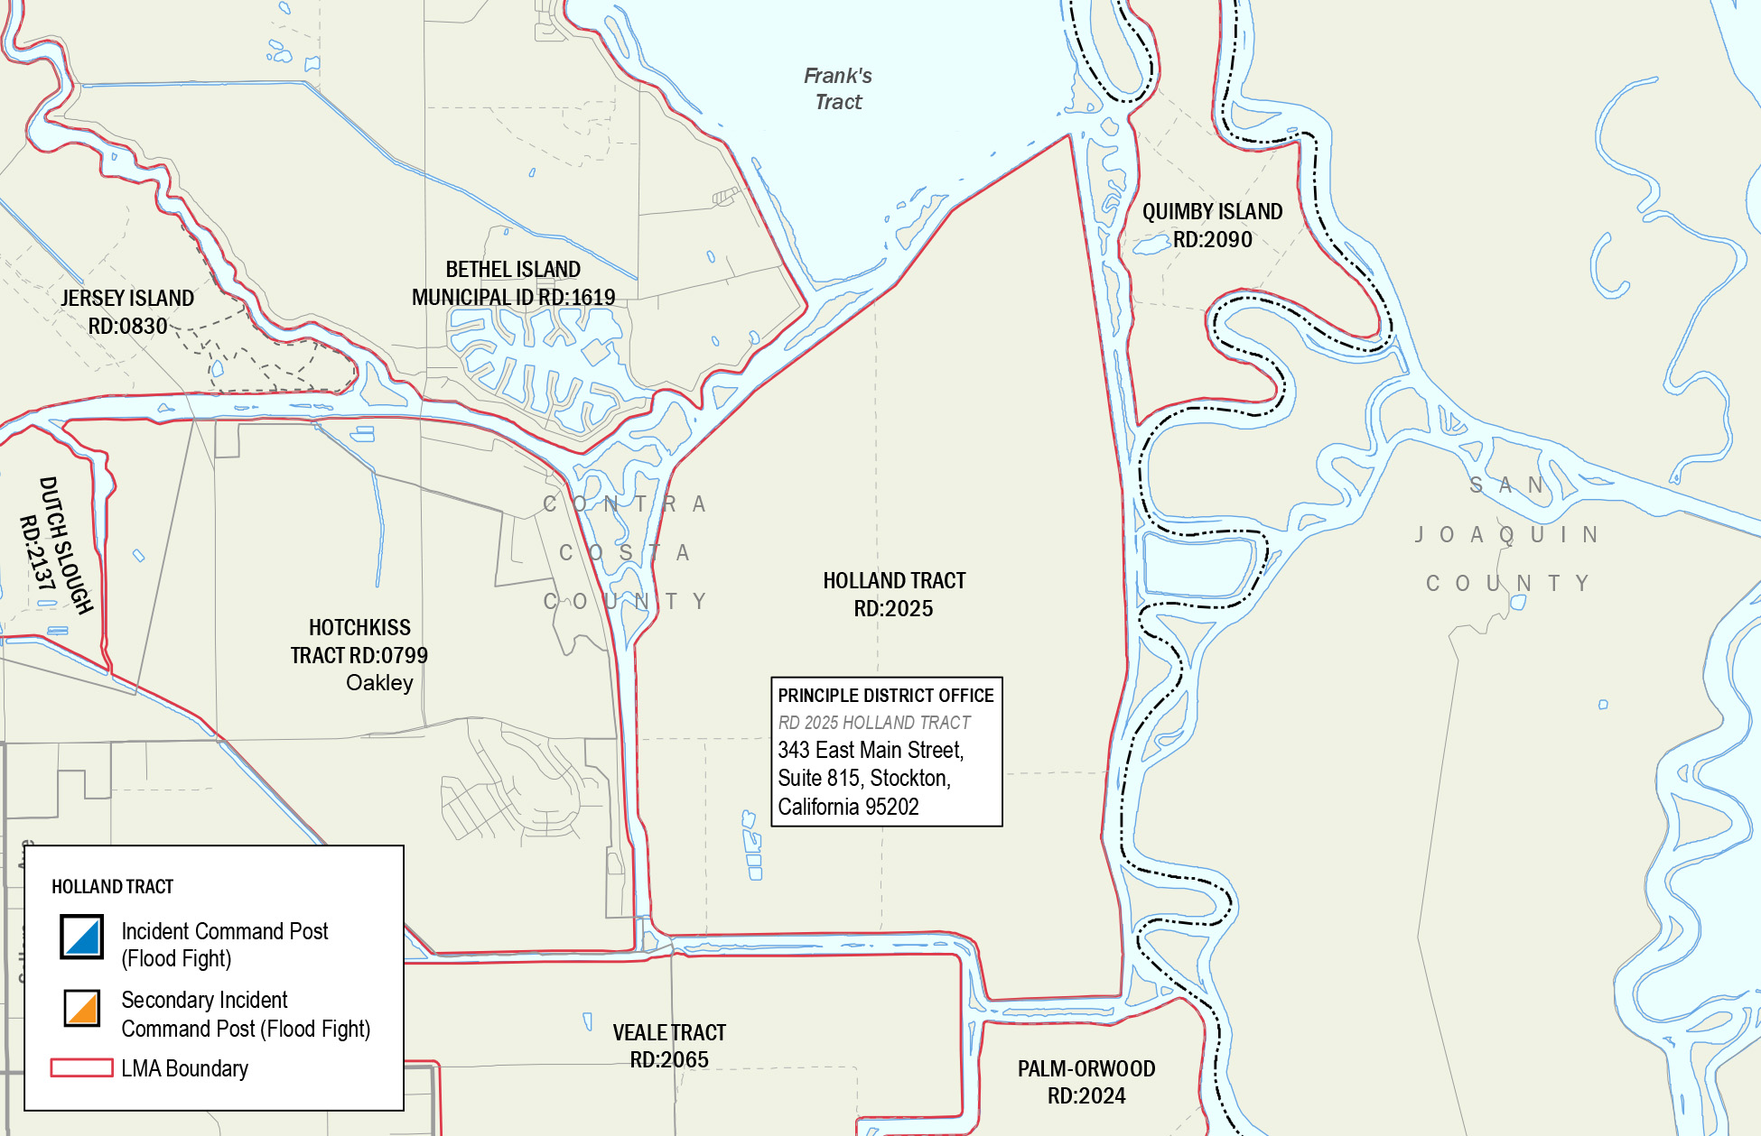
Figure 9: LMA Boundaries and Incident Command Post (ICP) Locations

Operational Area Emergency Operations Center
Contra Costa County maintains and hosts an operational area Emergency Operations Center (EOC) at 50 Glacier Drive in Martinez, California. The operational area management group (MAC) will prioritize allocation of resources including mutual aid, share information, and conduct coordination processes in accordance with the multi-agency coordination system (MACS) procedures maintained by the Contra Costa County Office of Emergency Services.
The Operational Area Planning/Intelligence Section may provide disaster intelligence and situational status to RD 2025 - Holland Tract upon activation in an emergency. Holland Tract does not attend operational area meetings and activities, but communication can occur via phone or internet-based solutions.
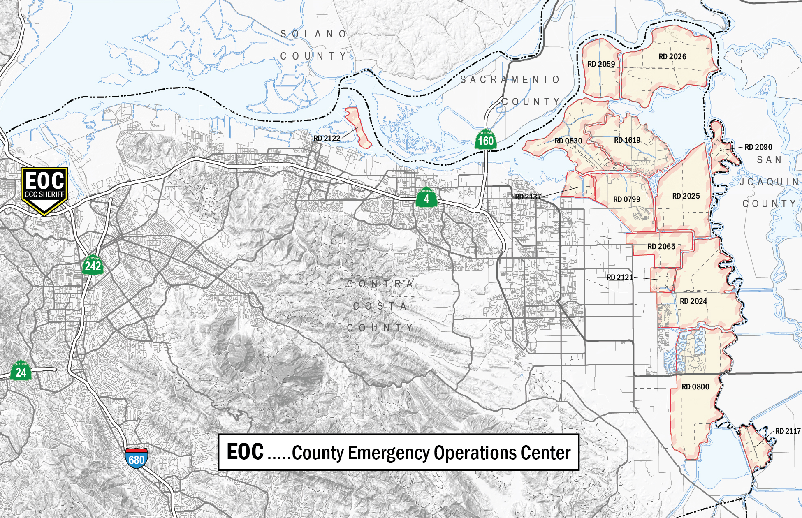
Figure 10: Regional EOC & ICP Map

State-Federal Flood Operations Center
DWR maintains the State-Federal Flood Operations Center (FOC) to perform these functions and support the operations of other State and Federal agencies. Holland Tract will maintain communication with the FOC in order to receive information from and provide information to that facility and to request technical assistance. Communication can occur via phone or internet-based solutions.

Operational Area Joint Information Center
Risk communication to the general public, including the seasonal workers and residents of Holland Tract, will also be coordinated, planned, and carried out through the Contra Costa County Operational Area Joint Information Center (JIC). Holland Tract will assist with communicating risk to its residents as requested through the Operational Area.
The District Engineer may serve as Holland Tract’s Information Officer as requested by the JIC and will have the authority to approve information releases.

INTENTIONAL BLANK PAGE

Communication

Communication Organization
Holland Tract maintains adequate communications equipment to implement this plan, which includes communicating with the following:
1) Holland Tract staff, contractors, and other personnel working under Holland Tract supervision;
2) Other public agencies that may be operating within Holland Tract;
3) Neighboring Reclamation Districts;
4) Contra Costa County Operational Area EOC; and
5) State Flood Operations Center.

Communication within Holland Tract
Holland Tract’s equipment ensures that communication with the following can take place:
1) Holland Tract staff;
2) Levee patrols; and
3) Holland Tract staff, contractors, and volunteers conducting flood fight activities.
Cell phones and email are the primary communications equipment. No radios/frequencies or phone numbers have been assigned for particular functions.

Communication with Other Jurisdictions
The District will maintain communication with other jurisdictions by cell phones and by participation in meetings as appropriate.

Operational Area Emergency Operation Center
Holland Tract will establish and maintain adequate communication with the Contra Costa County EOC primarily via cell phones. The District office also has a land line and fax/email capabilities.

Department of Water Resources State-Federal Flood Operations Center
The District will communicate with the FOC by cell phone. Additional communications equipment may also be provided to ensure contact.
Table 3: Contact Information
COUNTY OFFICES
Contra Costa County Sheriff’s Office/Department | 911 or 925-646-2441
Contra Costa County Office of Emergency Services (OES) | 925-228-5000, 24-Hour
Contra Costa County Fire Protection District (Rescue) | 925-941-3330
Contra Costa County Public Works Department (Debris Management) | 925-427-8562
RESPONSE SUPPORT
DWR State-Federal Flood Operations Center  (Coordination for Support) | 916-574-2619
Caltrans (Evacuation/Bridge Support) | 916-654-2852
California Conservation Corps (Environmental/Disaster Response) | 916-341-3100
DISTRICT CONTACTS
Bixler Tract (RD 2121) | C: 925-550-5540  H: 925-634-0310
BIMID (RD 1619) | O:916-631-4534  C:916-505-4106
Bradford Island (RD 2059) | 925-684-3222 or 925-209-5480
Byron Tract (RD 800) | 925-634-2351
Coney Island (RD 2117) | 209-465-5883
Dutch Slough (RD 2137) | 209-943-5551
Holland Tract (RD 2025) | 209-943-5551
Hotchkiss Tract (RD 799) | 925-684-2398
Jersey Island (RD 830) | 925-625-2279
Palm-Orwood Tract (RD 2024) | 209-465-5883
Quimby Island (RD 2090) | 209-943-5551
Veale Tract (RD 2065) | 209-465-5883
Webb Tract (RD 2026) | 209-943-5551
Winter Island (RD 2122) | 925-432-3300 or 916.456.4400

Logistics and Finance/Administration

Mutual Aid
Holland Tract is a signatory to the California Master Mutual Aid Agreement and, therefore, follows the processes outlined in those documents and the California Standardized Emergency Management System (SEMS) for requesting and providing mutual aid. Additionally, mutual aid requests for technical assistance and services, flood fight crews, supplies and materials, and other resources can be made through the EOC representative in the Operational Area Logistics Section.

Resources
The District maintains a stockpile of riprap on the island and has limited access to landowner equipment to perform levee maintenance and repairs. If equipment is not available, work will be performed on a contract basis. The following resources are available on Holland Tract. The District also has access to additional resources from RD 756 – Bouldin Island, RD 2026 – Webb Tract, and RD 2028 – Bacon Island. See Table below of flood fight supply inventory.
Table 4: Flood Fight Supply Inventory
Description/units | Quantity on Hand
Visqueen Plastic, 100’ x 20’ x 10-mil roll | 5
Sandbag, Burlap, each | 5,000
Twine (250 lb.), box | 3
Wooden Stakes, each | 200
Tie Buttons, each | 1,400
Lineman Pliers, each | 5
Sledge Hammers, each | 5
Shovel, each | 6
Life Vests, each | 10
Survey Lathe, bundle | 2
Flagging Tape, red, white, pink and blue | 3 rolls of each
Permanent Marker, pack | 1
Pad/Pencil Set, each | 1
Spotlight w/extra battery, each | 1
Combo Lock | 1
Tool Box | 1

The District maintains standard forms and processes for initiating and executing contracts with private vendors. The District maintains a standard sole-source contract form for contracts under $25,000. The District maintains a separate contract form for contracts over $25,000, adding bonding requirements. Contracts over $25,000 will be awarded through an informal bid process, if practicable in light of emergency conditions.

Logistics Facilities
The following map illustrates the locations of flood fight supplies and riprap. The District Engineer coordinates contracts and allocation of resources and makes decisions based on the situation at hand, in coordination with the trustees. Refer to Annex A – Flood Contingency Map for more information on the process for activating and establishing such supply staging areas or for mobilizing stockpiles.
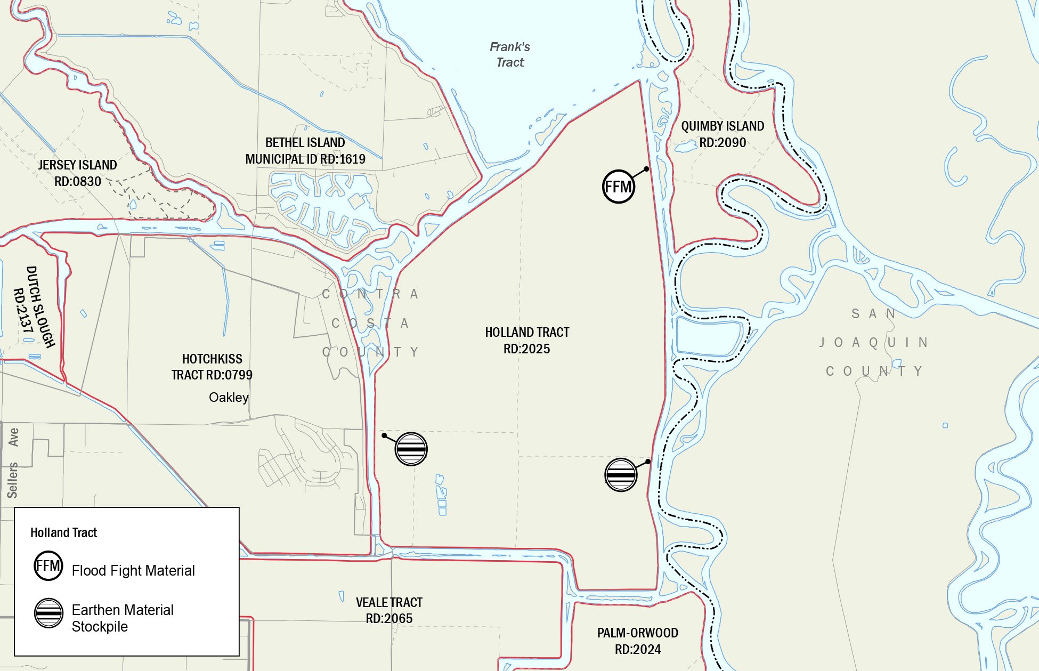
Figure 11: Pre-positioned Flood Fight Materials, Supplies, and Headquarters

Finance and Administration
The District maintains financial and administrative records associated with emergency response in accordance with 44 C.F.R. Part 13--Uniform Administrative Requirements for Grants and Cooperative Agreements to State and Local Governments. Emergency response and construction records, including field reports and procurement and construction management files, are maintained by both the District and the District Engineer and are retained as prescribed by the grant authority.

New Building Requirements
Per California Water Code 9650, there is a requirement to the extent reasonable, that either of the following applies to a new building in which the inhabitants are expected to be essential service providers:
(A) The building is located outside an area that may be flooded.
(B) The building is designed to be operable shortly after the floodwater is removed.

Plan Review and Maintenance

Plan Review and Maintenance
Holland Tract and individuals providing emergency response will review this plan at least annually.
In addition, this plan may be modified as a result of post-incident analyses and/or post-exercise critiques, and changes shall be published and distributed to the Contra Costa County Office of Emergency Services. This plan may also be modified whenever responsibilities, procedures, laws, rules, or regulations pertaining to emergency management and operations change.

Training and Exercises
Holland Tract staff should receive annual refresher training on the Holland Tract LFSP – Basic Plan and Annex A – Flood Contingency Map.
Holland Tract staff can also participate in internal exercises sponsored by the Contra Costa County Operational Area if requested.

Emergency Response and Training
The following are emergency response and training options.

Emergency Response
In an emergency, Holland Tract staff are responsible for determining a general response policy and performing financial oversight. They are responsible for organizing response activities, supervising any hired staff or contractors, and coordinating with outside agencies.
Training should be tailored to the level of incident complexity that these staff would potentially manage.

Training Requirements
The following training requirements should be considered for Holland Tract staff involved in flood emergency operations:
Prior to beginning work, staff hired or transferred to serve as Emergency Levee Workers at the time of an emergency should receive the 2-hour ICS-100 and ICS-200 courses and specific procedures and safety information for their emergency duties.

Plan Evaluation
The District Engineer should coordinate and facilitate post-incident analyses following emergencies and exercises. An After-Action Report and Implementation Plan should be prepared to capture lessons learned and plan improvements.

INTENTIONAL BLANK PAGE

Authorities and References
The following sources provide authorities for planning, conducting, and/or supporting flood emergency operations.

Federal
- Federal Civil Defense Act of 1950 (Public Law 920, as amended)
- Robert T. Stafford Disaster Relief and Emergency Assistance Act of 1988 (Public Law 93-288, as amended)
- U.S. Army Corps of Engineers Disaster Operations (Public Law 84-99)

State
- California Emergency Services Act (Chapter 7, Division 1 of Title 2 of the Government Code)
- Standardized Emergency Management System Regulations (Chapter 1 of Division 2 of Title 19 of the California Code of Regulations)
- California Department of Water Resources Flood Control (California Water Code §128)
- Hazardous Materials Area Plan Regulations (Chapter 4 of Division 2, Title 19, Article 3, §2720-2728 of the California Code of Regulations) and California Health and Safety Code, Division 20, Chapter 6.95, Section 25503.5

Local
- Holland Tract Local Flood Safety Plan
- Contra Costa County Emergency Operations Plan

INTENTIONAL BLANK PAGE

Glossary of Terms/Acronyms

CDAA | California Disaster Assistance Act
CDEC | California Data Exchange Center
CEQA | California Environmental Quality Act
DWR | Department of Water Resources
EOC | Emergency Operations Center
FEMA | Federal Emergency Management Agency
FOC | Flood Operations Center
ICP | Incident Command Post
JIC | Joint Information Center
LFSP | Local Flood Safety Plan
LMA | Levee Maintaining Agency
MACS | Multi-agency coordination system
NOAA | National Oceanic and Atmospheric Administration
OES | Office of Emergency Services
PED | Preliminary Engineering Design
RD | Reclamation District
REOC | Regional Emergency Operations Center
SEMS | Standardized Emergency Management System
USGS | United States Geological Survey

INTENTIONAL BLANK PAGE
- Flood Contingency Map
Flood fight operations, including levee patrols, will be conducted in accordance with the procedures shown below and those shown on Annex A – Flood Contingency Map.

INTENTIONAL BLANK PAGE
- Increased Readiness Checklist
This Increased Readiness Checklist applies to a developing situation in which the levees are not in danger of failing. In many cases, these unusual events are remedied, with no further action required. Residents may need to be notified if flooding threatens life or property, but it should be made clear that the levees are safe.
 | TASK/ACTION | COMMENT | STATUS  Assigned/Completed
Increased Readiness Checklist
1 | Upon notification of potential emergency/disaster, adopt an increased readiness posture by LFSP, maps, and mutual aid agreements (if applicable) |  | □ Assigned  □ Completed  □ N/A
2 | Consider alerting/recalling off-shift Holland Tract staff/volunteers |  | □ Assigned  □ Completed  □ N/A
3 | Assess the availability and condition of resources |  | □ Assigned  □ Completed  □ N/A
4 | Anticipate logistical needs (potential resupply needs, etc.) |  | □ Assigned  □ Completed  □ N/A
5 | Anticipate specialized equipment needs and inspect operational status (backhoes, crawler tractors, self-priming pumps, etc.) |  | □ Assigned  □ Completed  □ N/A
6 | Provide status report to County OES |  | □ Assigned  □ Completed  □ N/A
7 | Stage equipment and material in strategic locations as deemed necessary |  | □ Assigned  □ Completed  □ N/A

INTENTIONAL BLANK PAGE

- Flood Water Removal (Dewatering) Options
With the overtopping or failure of a levee flood protection system, the lands protected by the levee system may become partially or fully inundated. Depending on the situation, the area may need to be dewatered immediately to prevent further flooding or to protect the overall integrity of the flood protection system, or the water may need to be removed to return the area to pre-flood conditions. Flood water removal is an integral part of flood emergency response and needs to be considered in planning for floods. Flood water removal projects are generally exempt from the California Environmental Quality Act (CEQA). Statutory exemptions include “emergency projects such as actions required to restore damaged facilities or mitigate an emergency.” The following describes flood water removal options to dewater areas protected by a levee system.
Option 1 – No Immediate Dewatering Needed
Based on the situation, it may be advisable to take no immediate action. For example, an inundated agricultural area creating no threat to life and property may be left flooded until waters recede naturally. Due to public perception and expectations, this may be a difficult decision to reach, albeit logical. For some areas, this choice can be made in advance of a flood event.
Option 2 – Close Breach but do Not remove Water
Closing the opening in a failed levee is generally the first step of any levee breach repair. It may be necessary to wait for the inflow to slow before taking this action. Rock and suitable materials must be available to armor the ends of the break before closing the opening with additional suitable material. After the breach is closed, it may be cost-effective to simply let the ground dry out on its own, depending on the extent of the flooding.
Option 3 – Repair Breach and Remove Water by Pumping
After a breach is closed, water can be removed using available on-site or perhaps portable pumps. For large flooded areas, the time and expense for this work can be extensive. Providing information on pump suppliers, possible locations for pumps, and other logistics before the event should be part of the plan. The District may choose to pump floodwater back into the nearby channels, provided the action does not increase the chance of flooding on adjacent islands.

INTENTIONAL BLANK PAGE
- Action and Event Progression Log
CONFIDENTIAL INFORMATION – DESTROY BEFORE DISCARDING
Date | Time | Action/Event Progression |  |  | Taken by
Report prepared by: |  |  | Date:

INTENTIONAL BLANK PAGE
- Emergency Personnel Contacts
The following emergency personnel will be contacted for a developing situation in which the levees are not in immediate danger of failing. If a failure is imminent, call 9-1-1.
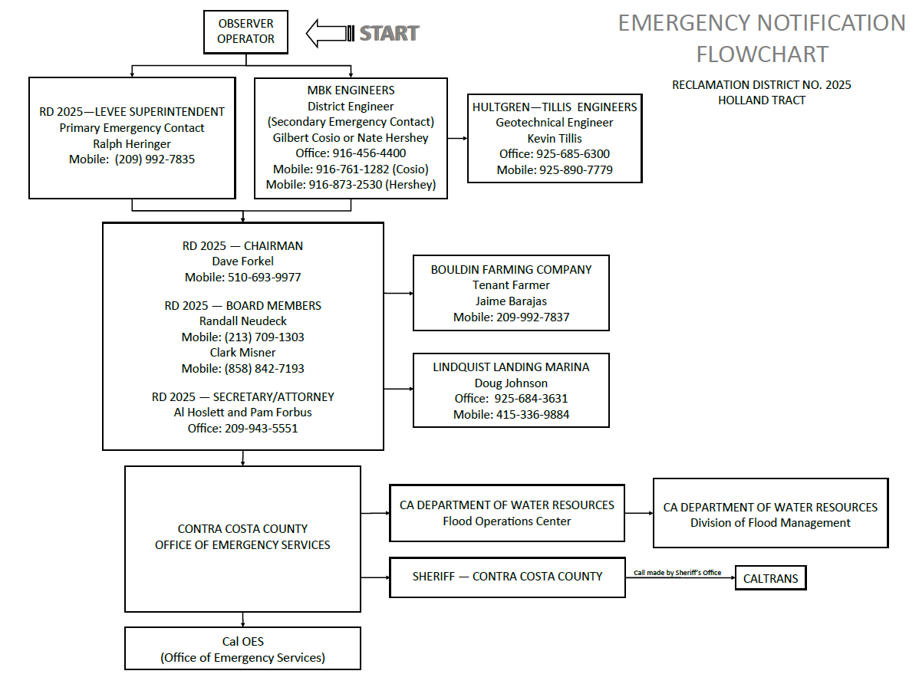

INTENTIONAL BLANK PAGE

Depending on whether the levee is a “project levee,” “direct agreement levee,” or “non-project levee,” current conditions and maintenance programs vary greatly for over 1,100 miles of levees in the Delta region. Under the authority of Public Bill No. 392, approved August 26, 1937, by the 75th US Congress, both the Sacramento and San Joaquin Project Levees are maintained and operated by the DWR through maintenance and operational assurances from local operating and maintaining partners like RDs and Maintenance Districts.
The king tide is the highest predicted high tide of the year at a coastal location. It is above the highest water level reached at high tide on an average day. King tides are also known as perigean spring tides.
The king tide is the highest predicted high tide of the year at a coastal location. It is above the highest water level reached at high tide on an average day. King tides are also known as perigean spring tides.
The Pineapple Express meteorological phenomenon is associated with heavy precipitation from the waters adjacent to the Hawaiian Islands and can extend to any location along the Pacific coast of North America.

